**PROJECT PROTOTYPE**

Project Title: Trends in Human Development Team members:

1) Name: Saju Saha; Email:[ujas093017@gmail.com](mailto:ujas093017@gmail.com); A#:A02270121

2) Chetan Birthare; Email:[chetan16994@gmail.com](mailto:chetan16994@gmail.com) ;A#: A02315458

3) Supratik Chanda; Email:[supchanda08kol50@gmail.com](mailto:supchanda08kol50@gmail.com); A#: A02273230

GitHub repository link: <https://github.com/SupChanda/Data-Visualization-Project->

***Overview and Motivation:*** Human Development Index is a widely accepted yardstick of assessing progress in development. This was designed to measure multiple dimensions like health, education, employment, and income. Since we found out that from 1990 to 2019, HDI is calculated on the rates of literacy, school enrolment, as well as life expectancy and many more, we thought of creating a project where we, with the help of categories, can precisely visualise a broad view of world development parameters. These attempts of providing meticulous visualization will be directed towards analysing various parameters of living standards and will also help in giving proper evidence of progress of human capabilities. The above concepts made us choose the HDI project, where we analyse and present a fuller picture of every country’s human development status using various indicators and presenting in a data visualisation format.

#### Related Work: **We were engaged in  taking ideas from numerous projects, many of which have precise connections of the data added with exquisite visualizations. On going through the projects from Hall of Fame ,given by Dr. Edwards, our eyes were glued on two projects: “Winner: Visualizing Flight Punctuality in the United States**” **and “840 Jobs”.  On opening the project website, the visualization effect really caught our attention. We liked the display of airports’ size in circles all over the United States. Moreover, we truly liked the homework 6 assignment design and visualization. That being used, we inculcated the year chart and the World Map idea from the assignment . We got the rough idea of data also from 840 jobs project. Since, they played with the educational data, we thought of implementing an equivalent idea with the human development index.**

#### **Inspirations of visualization found online:**

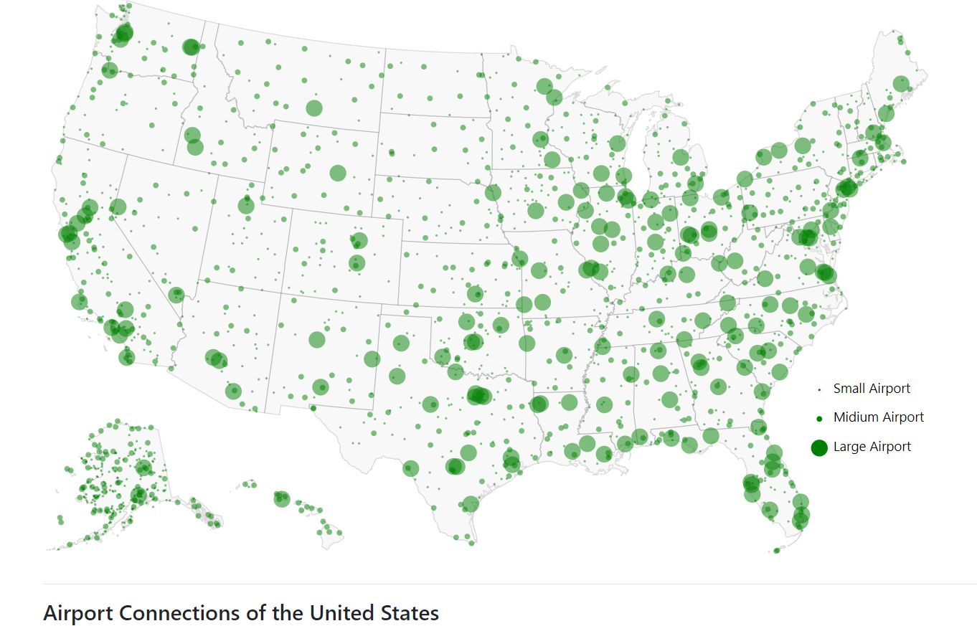

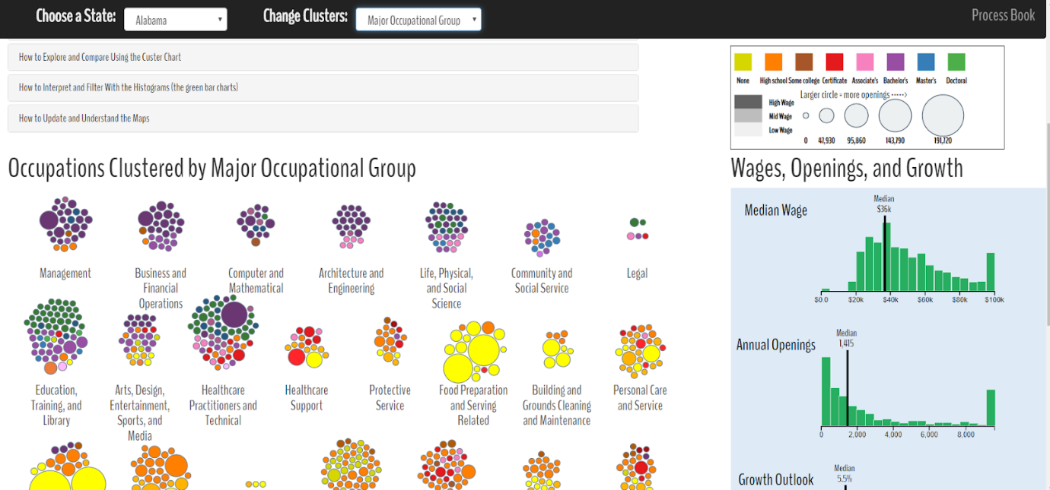

**QUESTIONS ARISED****and****HOW DID THESE QUESTIONS EVOLVE OVER THE COURSE OF THE PROJECT??**

1.How performance of each country varied from 1900 till 2017?

Since it was a dataset for long period of time, it became necessary to find a way to enable user, view trends over a decade. So, we implemented a next button to enable the user visit HDI changes for different years and also select a specific year from the list. We are using a drop-down list to visualize each country based on population. User can change the drop-down value from HDI to Population to see the trend of population of each country according to its colour.

*Note:* Please open the YouTube video in the browser for a full view.

[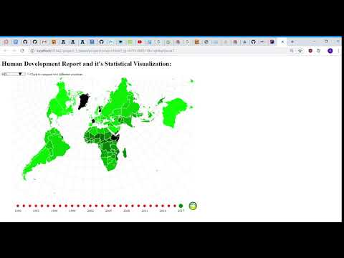](https://www.youtube.com/watch?v=AaxJCluJDB0)

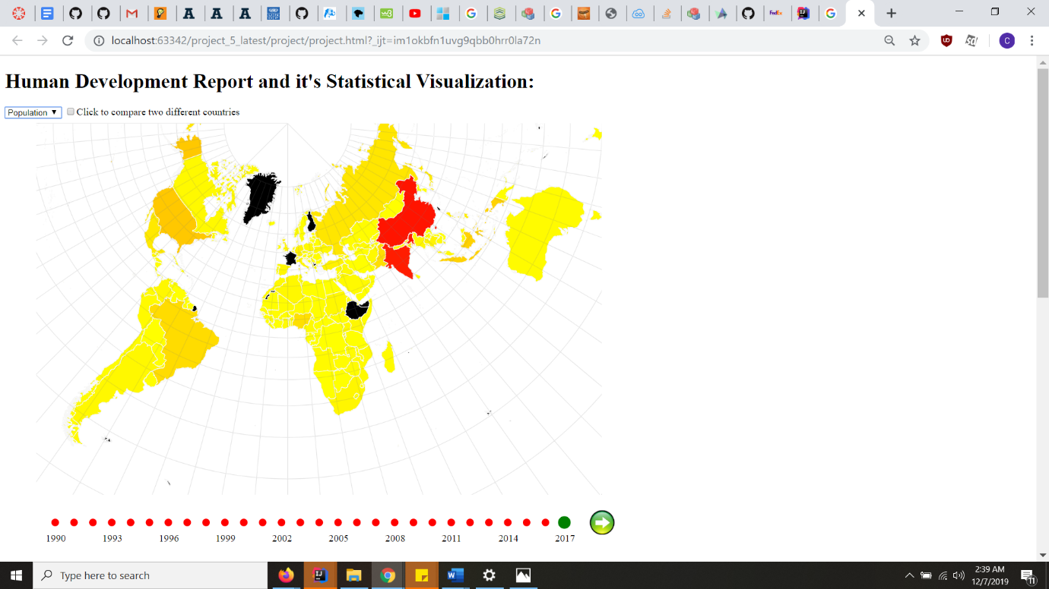

2.How to visualize performance of all countries in a single world map?

It was not impeccable and at the same time meticulous to show human development rankings of 126 countries in an isolated way and not everyone is an ace in geo-graphical views of all the countries. So, we decided to visualize individual performances of all countries in a single world map. To differentiate every country, we are using a colour hue. The lighter the colour, the more the HDI value for that country:

Exception: Our data doesn’t contain HDI features of some of the countries. The left out countries are coloured black.

3.How to get basic info about any country by just a click on world map?

What if a user sees an outlier (a country having absolutely different ranking/performance compared to its surrounding country)  in a particular region and user is curious to know basic information about that country, then it makes sense to provide information about a specific country on a click of a button in world map.

For eg, if user wants to find country with worst HDI in Africa, he scrolls over it, but never heard the name of that country. So he can click over it and get to know about the basic information about that country in info panel. Like GDP ranking etc.

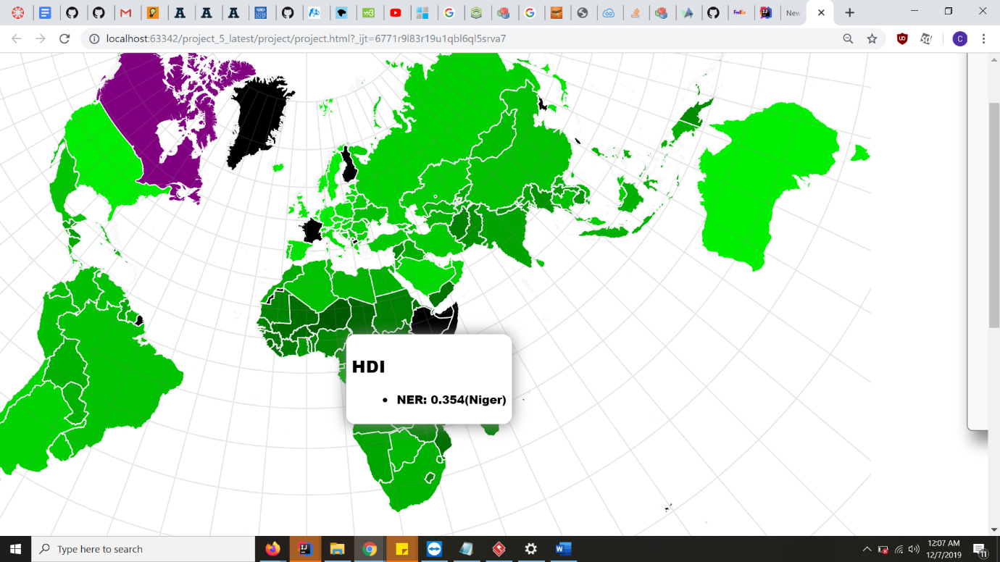

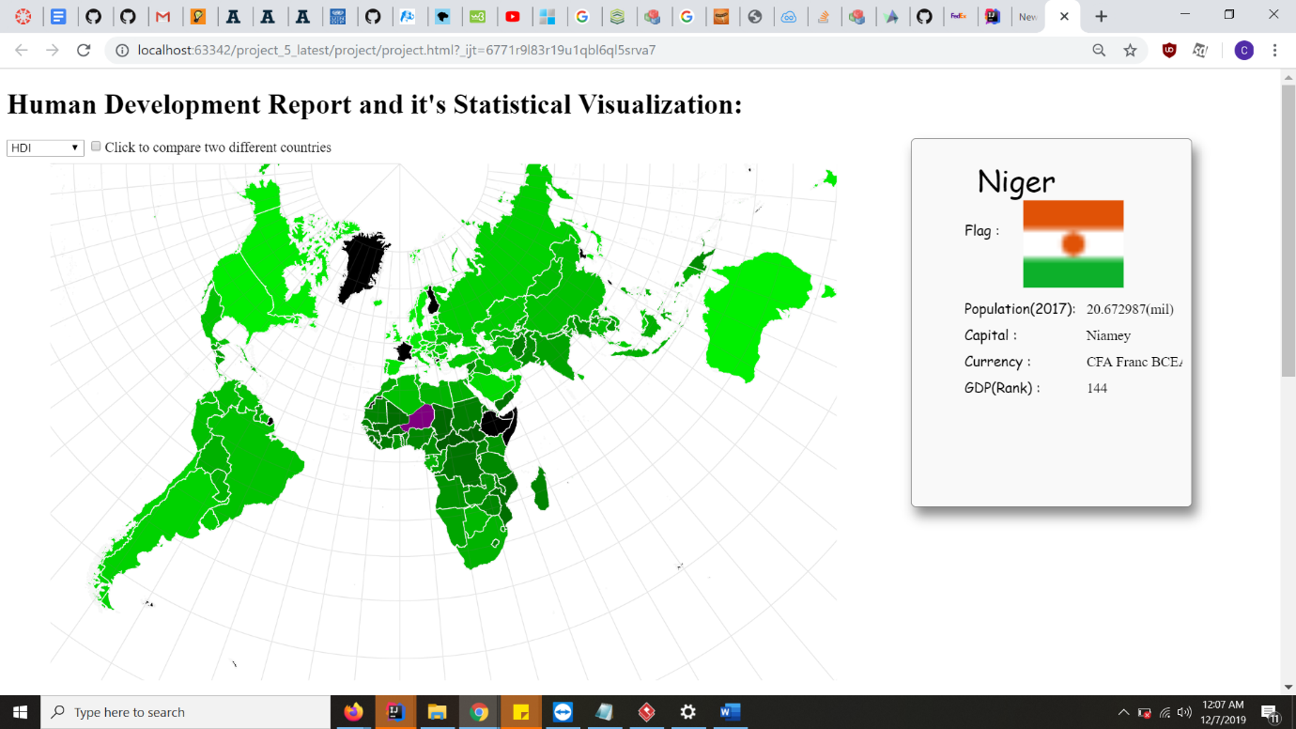

4.How to view performance of a particular country in specific HDI category which can further be seen in detail if one wishes to (sub-category) at a single place in an interactive way?

A donut chart pops out allowing the user to query a HDI category of his choice. Because not all user may be interested in a every kind of HDI category, so he/she can click on any category of their liking to dig in deeper into that category.

Once the user clicks on a category, another donut chart will display which will show all the sub-categories of the clicked category. When the user further clicks on that sub-category, the trend of the selected sub-category under the already selected category for that country will be shown in the form of a line chart with data points shown in circles. Now, by looking at the line chart of its sub-category, it gives a really good idea of the trends over the years.

For eg, a social activist may be more interested in gender and inequality data, an environmentalist may be interested in environmental sustainability data trends of a country.

By hovering on the dots in line chart, user can get to know the exact value of that specific sub-category for any specific year.

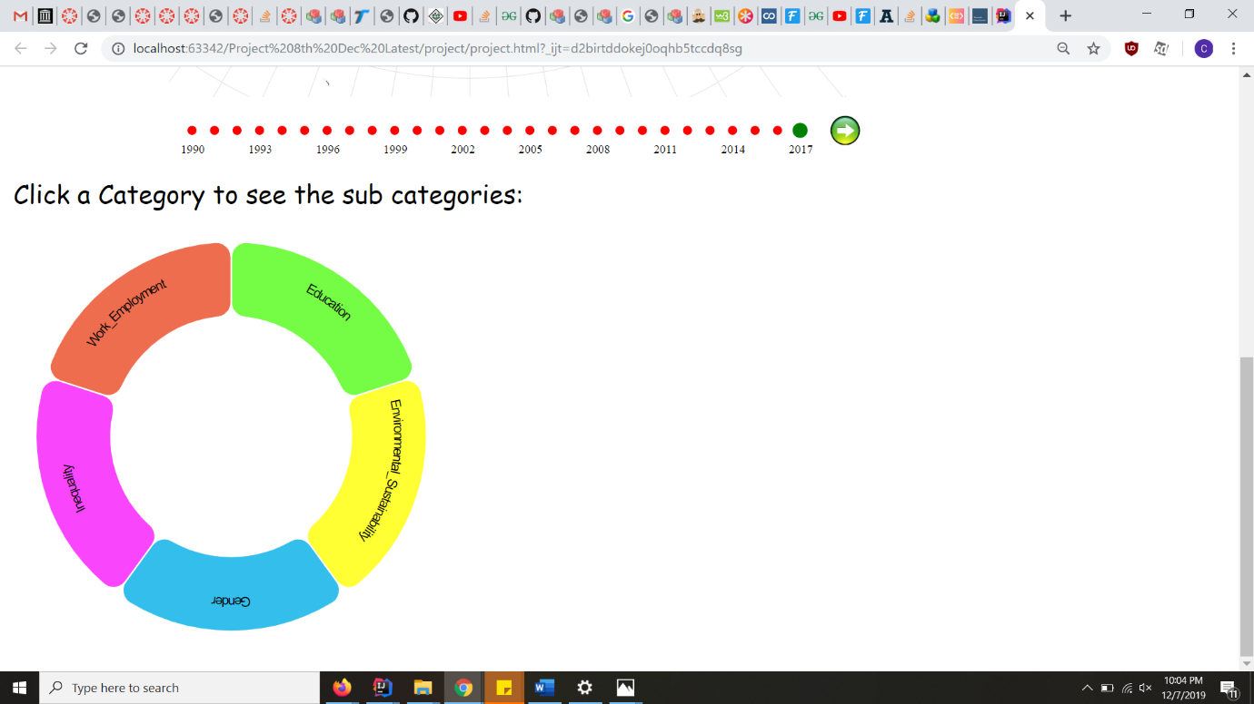

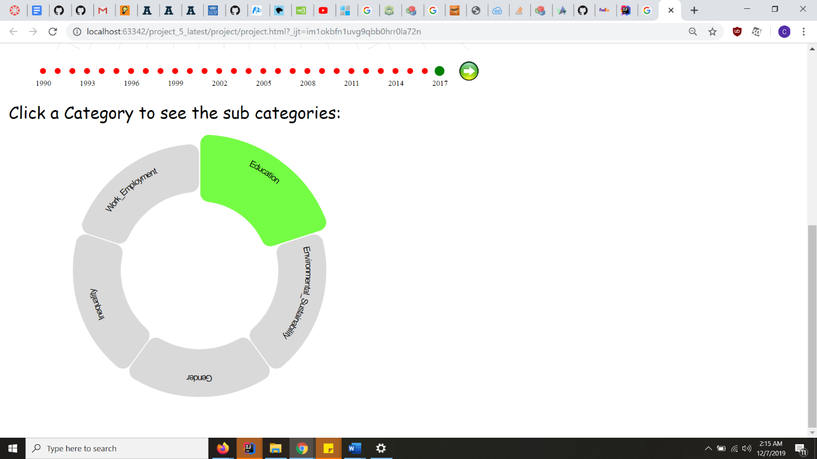 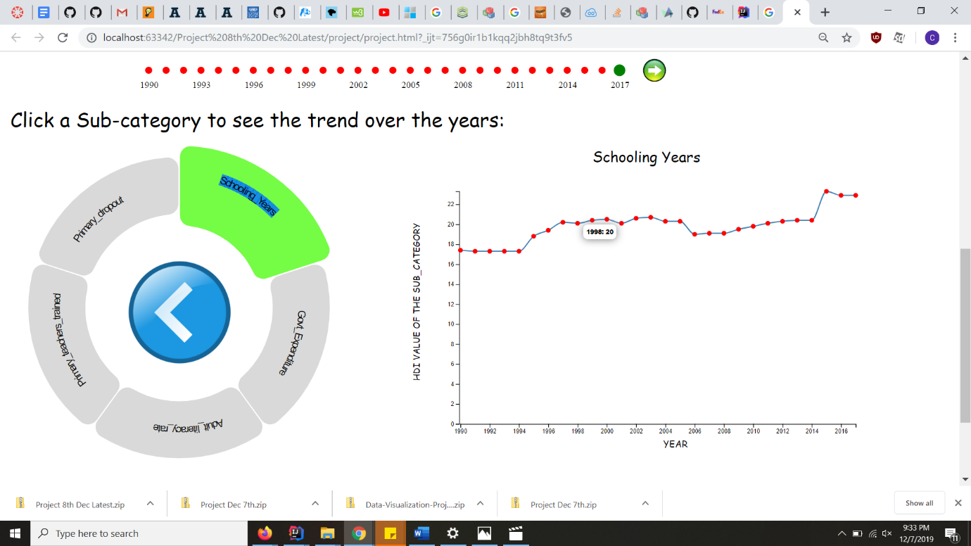

5.How to compare performance of two countries in specific Human development index we want to, that to by just choosing both countries via click on world map?

It would be really cumbersome to search 2 country names out of 216 from a drop down list. So we have made sure that user don’t have to go through that pain and can select 2 countries for comparison just on a click. First, the user will select a checkbox for comparison and then click 2 countries he wants to compare one by one.

Its another advantage is that, the user doesn’t have to bother about the name of a country.

For example, while watching population data on world map, user finds India and China to be most populated, but he doesn’t not want to bother about knowing their exact names, he can just select both countries on map and compare their performance under various categories.

On clicking any category in donut chart, a horizontal grouped bar chart pops out which compares performance of both countries in various sub-categories of the selected category.

He/she can further click on any sub-category in donut chart to see the detailed comparison in a year line chart.

User can click on the back button in the middle of donut chart to go out of sub-category menu to the category menu.

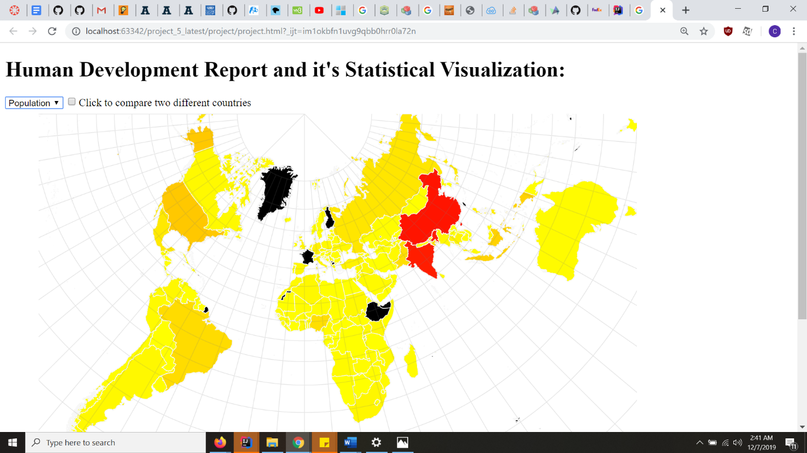

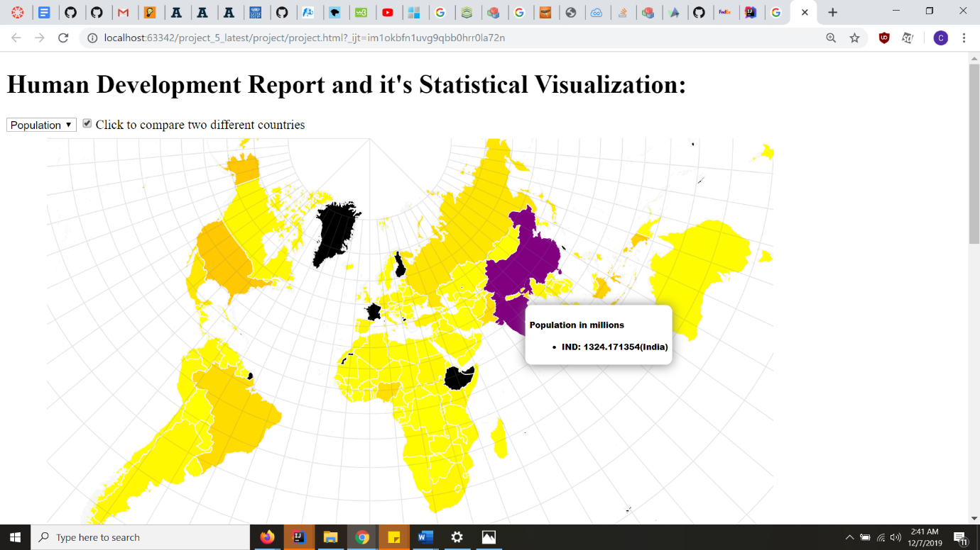

1.Before Hovering



2.After hovering:

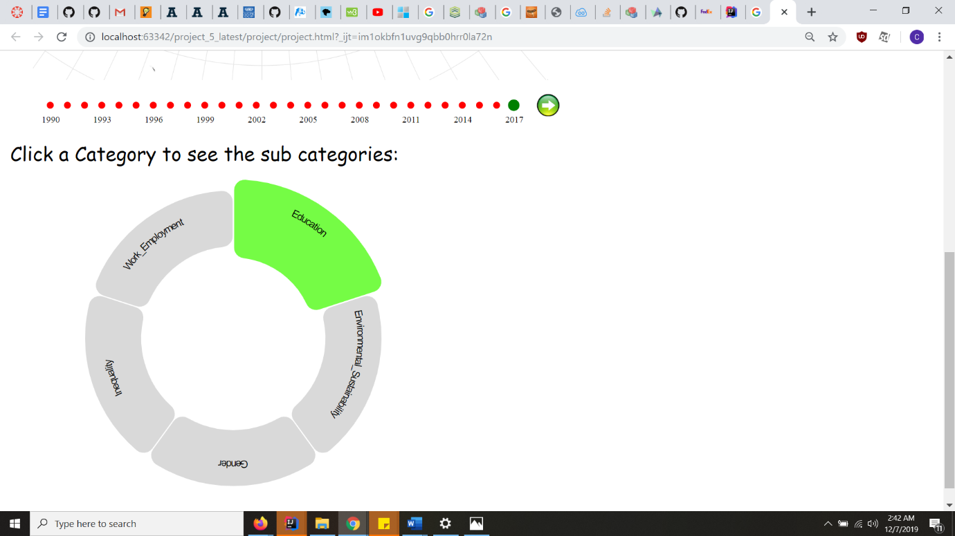

3.On clicking a category:

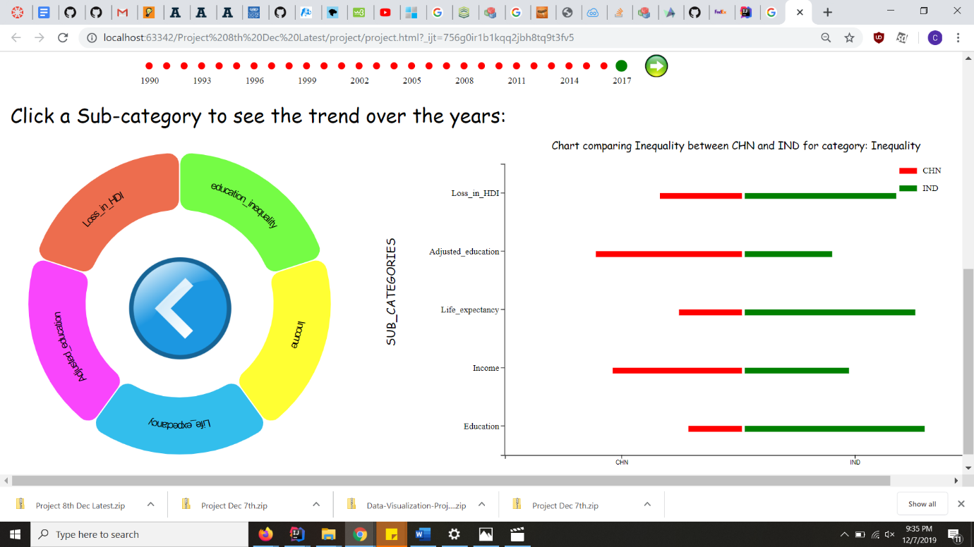

4.On clicking a sub-category

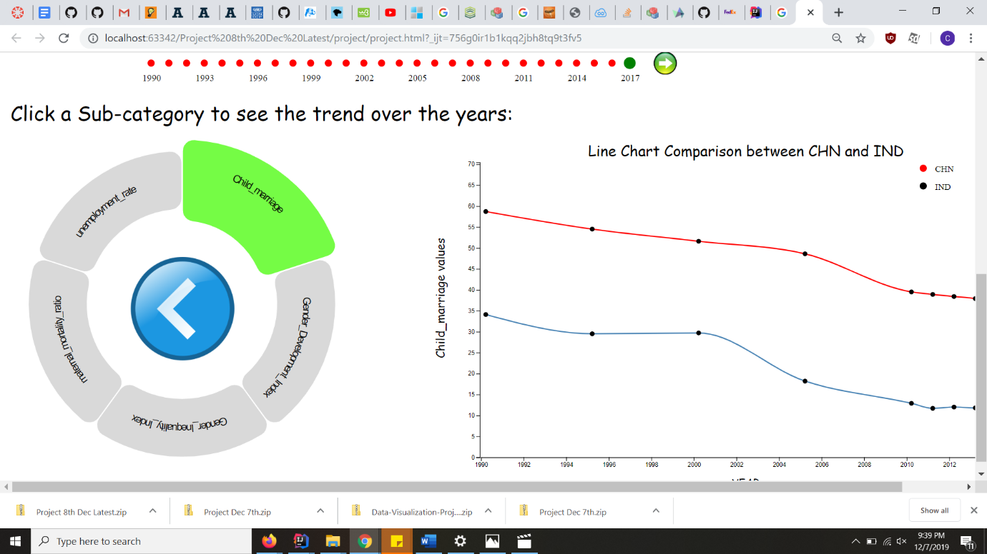

**What new questions did you consider in the course of your analysis?**

1. How did the HDI index and population varied over the years for a country.
2. What are the basic informations displayable for a country, that a user may want to know?
3. On comparing two countries, which country is more progressive for a certain category?( This is shown by horizontal grouped bar chart)
4. Which country among two clicked countries, have more value for a certain sub-category ( This is shown by two lines representing two countries in a line chart)
5. What is the trend of a country for a certain sub-category?

***Data:***

 We have gathered data from United Nations Developments Programme website under Human Development Reports section (<http://hdr.undp.org/en/data> ) as it was the most credible and complete source of dataset available over internet. Data was available for each human development index which is further divided into sub-categories for all countries. We have downloaded and used data for only those categories which we wanted to use for our project (like Demography, Education, Environmental sustainability, Gender, Inequality). We are also trying to scrape the data for getting the information such as population, flag image, area etc. But we are in the process of that and it will two or three days more. We are confident of getting the required data.

#### 

***Exploratory Data Analysis:***

Initially, looking at the data we were convinced that it is necessary to show data of all countries in a single view that too in a comparative way, instead of in isolation. Hence we thought of using map with hue. And since data was from time interval (1900 to 2017) we thought of giving user an option to change year, so that he can see the trends which is necessary to derive a meaningful information from data.

Another thought that came to our mind was that not all data of 216 country will be of special interest to every user. So we thought of enabling user to compare data of the countries he is interested in.

Since, the HDI data has different category, we have to give users a kind of query tool to dig in the details of only those category that he wishes to. Here, donut chart appears to be the perfect fit.

***Design Evaluation:***

Creating a meaningful visualization requires you to think about the story, the aesthetics of the visualization and various other aspects. Keeping that in mind, for the project till now, we considered a year chart , a world map, an info Panel and a play button. We used the world map because a world map is extremely powerful when it comes to handling geographical information. The data that we stored is in JSON format, so it should compatible to use it for world map creation. We just need to define the size of the map and the geographic projection to use later for further interactivity. Furthermore , the HDI index is available for every country of the world, so a map would justify the purpose in showing the HDI for every country. Also, since we had the TopoJSON file, it eliminated redundancy by storing relational information between geographic features, not merely spatial information. As a result, the interactive geometry is much more compact and combined where geometries share features such as HDI etc.

The other map that we roughly thought is Leaflet. It is a great alternative to Google Maps. It is an open source JavaScript library designed to make mobile-friendly interactive maps, with simplicity, performance and usability in mind. Leaflet is at its best when leveraging the big selection of world maps that are available around the internet and brings the simplicity of working with tiled maps and their presentation capabilities.

A year Chart is designed to show the HDI of every country. The main purpose of using the year chart is to represent the map with  different colours, whose density will be directly proportional to the HDI over a period of one year. Since, a year chart will be useful to track changes of HDI over a period of  one year, we used it as a visualisation design.

We have used a horizontal grouped bar chart to compare two countries on the basis of a category. The y-axis of the chart will be showing the further sub-categories and x-axis will be for two countries to be compared (displayed in red and green colour). We thought that it will be appropriate to show all sub-categories at a single place because he may or may not want to know all details about all sub-categories and we have given a tooltip to show exact value of any country’s sub-category just in case, he wants to look at it without going to year line chart.

Lastly, we created the info Panel keeping in mind to display the fixed attributes of a country such as flag, national anthem, area, latest population etc. This is to provide aquick overview of a simple infographic content of a country.

Initially, we were planning to use the area of circle to denote the percentage of HDI category for every country in a map. But since, it was not possible to compare HDI performance of country of bigger size with a smaller one by using area of a circle.

For example, if bhutan is having excellent HDI index in any category and india is having far worse. Then, ideally the area of circle for bhutan must be significantly larger than area of circle for india. But when we compare the size of both countries on map, it looks really awkward.

Hence, we are using color Hue instead of area of circle now.

We also now using a “next” button to select year instead of using brushing technique.

***Implementation:***  Web mapping in D3 js allow for animation, visualization, and interaction. We can also coordinate charts and plots with your map. In this project, we used the map chart and tooltip to visualize the HDI index rating for every country.

Tooltip is used or showing the HDI value on hovering. This is to spread awareness of the current human development in a broad aspect to the common mass.  The same purpose has been fulfilled using choosing population and not HDI from the drop down list positioned on the top left side of the html page. As said earlier, the reason of year chart is to exclusively showcase the present human development index of the country in that year. Year chart brings a button which helps in clicking the specific year if the user chooses to see the desired year’s HDI. Next, the info Panel serves the purpose of displaying some other attributes for the general knowledge of the user.

On clicking the country, we drill down to the categories in the form of a donut chart. The purpose of using a donut chart and not a sun burst chart is because we have only two layers: category and sub-category. The data visualization will be compact with a donut chart. By further clicking a category, we come down to a sub-category. Eventually, when we click the sub-category we see a line chart displaying the trend of that sub-category over the years. The purpose of displaying the line chart is to show the ups and downs of the specific sub-category for a year.

We have implemented a checkbox to compare the categories and the sub-categories for two countries. This is an additional way for an user to compare the progress of two countries in terms of categories and sub categories. The horizontal bar chart shows which country is more progressive for which sub category and the grouped line chart displays which country has more value for a particular year for the selected sub-category

Note: All necessary screenshots and videos are already pasted in above sections.

The clear and well-referenced images are shown in the js file that we shown in the javascript file that we submitted along with this file

***Evaluation:***

We learnt that roadblocks are not fun but needed to create and finish a successful project. D3 has a vast library of methods and visualizations and is much more flexible. We first learnt tile maps, geo projection, connection of buttons with the map. We come to know the ways to customize different countries  according to a certain time period(year). And also, the play button teaches us the perfect amalgamation of the transition effect and the animation interactivity with the map.

We are in the initial stage. Further, we are thinking to activate a clickable function for all the countries. By this, we mean to create a sunburst chart of that country with the other human development parameters like education, democracy, health, employment etc. The donut chart will come into picture when the user will click the human development parameters and the country.

The only additional technique that we like to enhance in future is implementing a slider button. When a user clicks the button, it will automatically slide from 1990 to 2017.

The other budding thought that we would have liked to add on is changing the horizontal grouped bar chart according to changing of years.